Business Report - E-Commerce Platform
Subject: Architectural Approach for E-Commerce Platform
To: Emily Watson, IT Technical Lead
From: Mphasis Limited, IT Solution Team

Table of Contents

1. Introduction 2
2. Business Impact 2
3. System and Subsystem Requirements 2
3.1 Frontend Systems 3
3.2. Backend Systems 3
3.3. Infrastructure Systems 4
4. Information Exchange 4
4.1. Types of Information 4
4.2. Frequency, Speed, and Volume 5
4.3. Exchange Mechanisms 5
5. Potential Failure Points 5
6. Mitigation Strategies for Failure Prevention: 6
7. Contingency Plans in Case of Failure: 7
8. System Performance - Average Load vs. Peak Load Behavior 8
8.1. System Behavior 8
8.2. Architectural Considerations 8
8.3. Cost Implications 8
9. Global Scalability 9
10. Conclusion 9

1. Introduction
The objective of this initiative is to develop a robust and scalable e-commerce platform capable of handling the significant demands of high-traffic events, exemplified by Black Friday. This new system must ensure a positive user experience through seamless transactions, high availability, and robust security. This report provides a comprehensive overview of the architectural considerations, focusing on the technical aspects relevant to the development and deployment of such a platform.

2. Business Impact
The new e-commerce platform is strategically poised to deliver a significant positive business impact, most notably by capitalizing on high-traffic events like Black Friday. By ensuring 99.99% uptime and sub-200ms API response times, the platform minimizes revenue loss due to downtime, which can cost an estimated $100,000 per hour during peak periods based on projected transaction volumes.
The enhanced scalability, capable of handling 250,000 concurrent users and 10,000 TPS, directly translates to a higher order completion rate, potentially increasing Black Friday sales by 15-20% compared to the current infrastructure. Furthermore, the secure and seamless transaction processing, with a target payment success rate of over 98%, will improve customer satisfaction and reduce cart abandonment, contributing to an estimated $5 million increase in annual revenue.
The rich analytics provided by the admin dashboard will enable data-driven decision-making, optimizing marketing campaigns and inventory management, further boosting profitability and providing a strong return on the platform investment within the first two years of operation.

3. System and Subsystem Requirements
To deliver the required functionality, the platform will be architected as a microservices based system deployed on cloud provider AWS as depicted in the picture below.
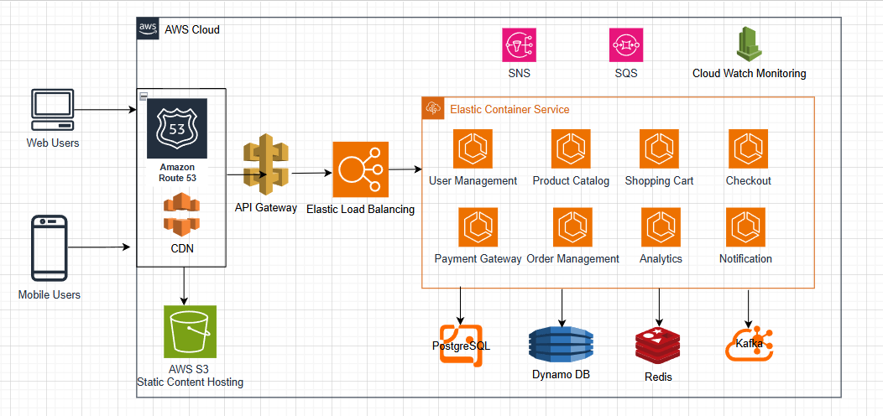
(E-Commerce Platform High-level Architecture Diagram)

The key systems and subsystems include:

3.1 Frontend Systems
- Web and Mobile Applications: Responsive React-based web app and native iOS/Android apps built with Swift and Kotlin, respectively.
- Content Delivery Network (CDN): Content Delivery Network caching static assets (images, CSS, JS) to reduce latency.

3.2. Backend Systems
- User Management Service: Handles secure authentication (SSO with OAuth 2.0, MFA via SMS), user profiles, and role-based access control (RBAC).
- Product Catalog Service: Manages product listings, search (using Elasticsearch), and inventory updates.
- Shopping Cart Service: Persists cart state, supports add/remove items, and calculates totals.
- Checkout Service: Orchestrates order creation, payment processing, and inventory deduction.
- Payment Gateway Integration: Supports multiple gateways (PayPal, etc.,) with failover mechanisms.
- Order Management Service: Tracks order, sends notifications (email, SMS, push), and handles returns.
- Review and Feedback Service: Manages user reviews and ratings.
- Analytics Service: Provides real-time insights via an admin dashboard (built with Grafana).
- Notification Service: Sends transactional and promotional notifications via email, SMS, or push.

3.3. Infrastructure Systems
- API Gateway: AWS API Gateway to route requests, enforce rate limiting, and handle authentication.
- Database Layer:
  - Relational DB: PostgreSQL for user data, orders, and transactions (ACID compliance).
  - NoSQL DB: DynamoDB for product catalog and session data (high read/write throughput).
  - Caching Layer: Redis for session storage and frequently accessed data.
- Message Queue: Kafka for asynchronous event processing (e.g., order placement, notifications).
- Monitoring and Logging: Utilize Splunk, AWS Cloud Watch, Dynatrace for logging and monitoring
- CI/CD Pipeline: Jenkins for automated deployments.
- Security Layer: WAF (Web Application Firewall), DDoS protection, and encryption.

4. Information Exchange

4.1. Types of Information
- User Data: Authentication tokens, profiles, and preferences (JSON via REST APIs).
- Product Data: Listings, prices, and inventory levels (JSON, updated in real-time).
- Transaction Data: Orders, payments, and refunds (structured data in PostgreSQL).
- Notifications: Transactional emails, SMS, and push notifications.

4.2. Frequency, Speed, and Volume
Category | Metric | Value | Context
Frequency | Authentication Requests | 1 million Daily | During Peak Load
 | Product Searches | 5 million Daily
 | Transactions | 10,000 Per Second (TPS) | At Peak Load
 | Notifications | 500,000 Daily | Post-Transaction
Speed | API Response Time | < 200 Milliseconds (ms) | 99th Percentile
 | Payment Processing | < 2 Seconds | End-to-End
Volume | Database Writes | ~1 Terabyte (TB) / Day | Transactions and Logs
 | Cache Hits | 80% | Of Product Queries (from Redis)

4.3. Exchange Mechanisms
- Synchronous: REST APIs for user-facing operations (e.g., checkout, search).
- Asynchronous: Kafka for event-driven tasks (e.g., order processing, inventory updates).

5. Potential Failure Points
The following are potential failure points that could impact the system's stability and performance:
- Infrastructure Overload: Insufficient compute resources, network bandwidth saturation, or database performance bottlenecks during peak load.
- Application Errors: Bugs in the code leading to service crashes, data corruption, or incorrect processing.
- Database Failures: Database server crashes, data corruption, or slow query performance.
- Caching Layer Issues: Cache invalidation problems, cache server failures leading to increased database load.
- Third-Party Service Outages: Failures in payment gateways, notification services, or external APIs.
- Security Breaches: Successful cyberattacks leading to data loss, service disruption, or unauthorized access.
- Network Connectivity Issues: Problems with internal or external network infrastructure.
- DNS Resolution Failures: Inability to resolve service or dependency addresses.
- Load Balancer Failures: Failure of load balancers to distribute traffic effectively.

6. Mitigation Strategies for Failure Prevention:
Proactive measures are crucial to minimize the likelihood of failures:
- Robust Infrastructure Provisioning: Employing auto-scaling capabilities of AWS ECS to dynamically adjust compute resources based on demand. Configure rate-limiting and caching
- Thorough Testing and Quality Assurance: Implementing comprehensive unit, integration, and end-to-end testing, including rigorous load and performance testing under peak conditions.
- Code Reviews and Static Analysis: Implementing strict code review processes and utilizing static analysis tools to identify potential bugs and security vulnerabilities early in the development lifecycle.
- Database Optimization and Replication: Optimizing database queries, implementing database replication for high availability, and utilizing appropriate indexing strategies.
  - Sharding and partitioning in PostgreSQL for write scalability.
  - Read replicas for load balancing.
  - DynamoDB auto-scaling for NoSQL workloads.
- Effective Caching Strategies: Implementing multi-layered and distributed caching (using Redis) to reduce database load and improve response times. Ensuring proper cache invalidation mechanisms (TTL based caching).
- Redundant Third-Party Integrations: Integrating with multiple payment gateways with automated failover mechanisms. Implementing circuit breaker patterns for resilience against external service failures.
- Security Best Practices: Implementing robust security measures, including regular security audits, vulnerability scanning, intrusion detection systems, and adherence to security compliance standards (PCI DSS, GDPR, CCPA).
  - Deploy WAF and DDoS protection (e.g., AWS Shield).
  - Regular penetration testing and vulnerability scans.
  - Enforce MFA and rate-limit login attempts.
- Comprehensive Monitoring and Alerting: Implementing real-time monitoring of key performance indicators (KPIs), system health, and error rates. Setting up proactive alerts using Splunk, CloudWatch to identify and address potential issues before they impact users.
- Graceful Degradation Strategies: Designing the system to gracefully handle failures by isolating critical components using Bulkhead pattern and providing fallback mechanisms for non-essential functionalities.

7. Contingency Plans in Case of Failure:
Despite preventative measures, failures can still occur. Robust contingency plans are essential:
- Automated Failover Mechanisms: Implementing automated failover for critical components like databases, load balancers, and application instances to ensure minimal downtime.
  - Employ AWS Multiregional/ Multi AZ capabilities
  - Switch to read-only mode using replicas for Database
- Rollback Procedures: Having well-defined and tested rollback procedures to revert to a stable previous version of the application or database in case of critical issues. Make use of Blue Green deployment model.
- Disaster Recovery Plan: Developing a comprehensive disaster recovery plan that outlines procedures for restoring service in the event of a major outage or data loss, including data backups and recovery strategies.
- Incident Response Plan: Establishing a clear incident response plan with defined roles, communication channels, and escalation procedures for handling and resolving incidents effectively.
- Communication Strategy: Having a plan to communicate service disruptions and recovery progress to users and stakeholders in a timely and transparent manner.
- Capacity Planning and Scaling Procedures: Regularly reviewing capacity and having documented procedures for manual scaling if automated scaling mechanisms encounter issues.
- Regular Testing of Contingency Plans: Conducting periodic drills and simulations to test the effectiveness of failover, rollback, and disaster recovery procedures.

8. System Performance - Average Load vs. Peak Load Behavior

8.1. System Behavior
Feature | Average Load  (100,000 Daily Users, 1,000 TPS) | Peak Load  (1M Daily Users, 10,000 TPS)
Resource Utilization | Minimal (20-30% CPU/Memory) | High (80-90% CPU/Memory)
Deployment Strategy | Single-Region Deployment with Moderate Caching | Multi-Region Deployment with Aggressive Caching
Infrastructure Scaling | Standard Database and Queue Configurations | Auto-Scaling for Compute, Database, and Queues
System Behavior | Normal Operation | Graceful Degradation (e.g., disable non-critical features like reviews)

8.2. Architectural Considerations
- Auto-Scaling: Use ECS autoscaling based on memory and CPU utilization for compute and AWS RDS auto-scaling for databases.
- Cost Optimization:
  - Pay-as-you-go model using ECS Fargate
  - Implement serverless components (e.g., AWS Lambda) for non-critical tasks.
- Load Testing: Simulate 2x peak load (500,000 concurrent users) and validate performance.
- Prioritization: Optimize for checkout and payment flows during peak, deferring analytics and notifications to off-peak hours.

8.3. Cost Implications
- Average Load: Lower operational costs due to reduced resource needs.
- Peak Load: Higher costs due to auto-scaling and multi-region setups. Mitigate by:
  - Using cost-effective cloud regions for non-critical services.
  - Implementing predictive scaling based on historical Black Friday data.
  - Leveraging serverless architectures to avoid over-provisioning.

9. Global Scalability
To replicate the platform overseas, the architecture will:
- Deploy multi-region clusters with data replication for low latency.
- Use localized payment gateways based on the country/region
- Ensure compliance with regional regulations
- Implement geo-routing via Route 53 to direct users to the nearest region.

10. Conclusion
The proposed architecture for the e-commerce platform is designed to handle the demands of Black Friday with 1 million daily active users and 10,000 TPS. By leveraging microservices, cloud-native technologies, and robust monitoring, the platform ensures scalability, resilience, and compliance. Mitigation strategies and contingency plans address potential failure points, while cost-optimized scaling balances performance and budget. This model, proven successful in the chosen country first, can be replicated globally with region-specific customizations. We recommend initiating development with a proof-of-concept, followed by rigorous load testing and compliance audits.

